**MYSQL EXERCISE 1**

**1.**

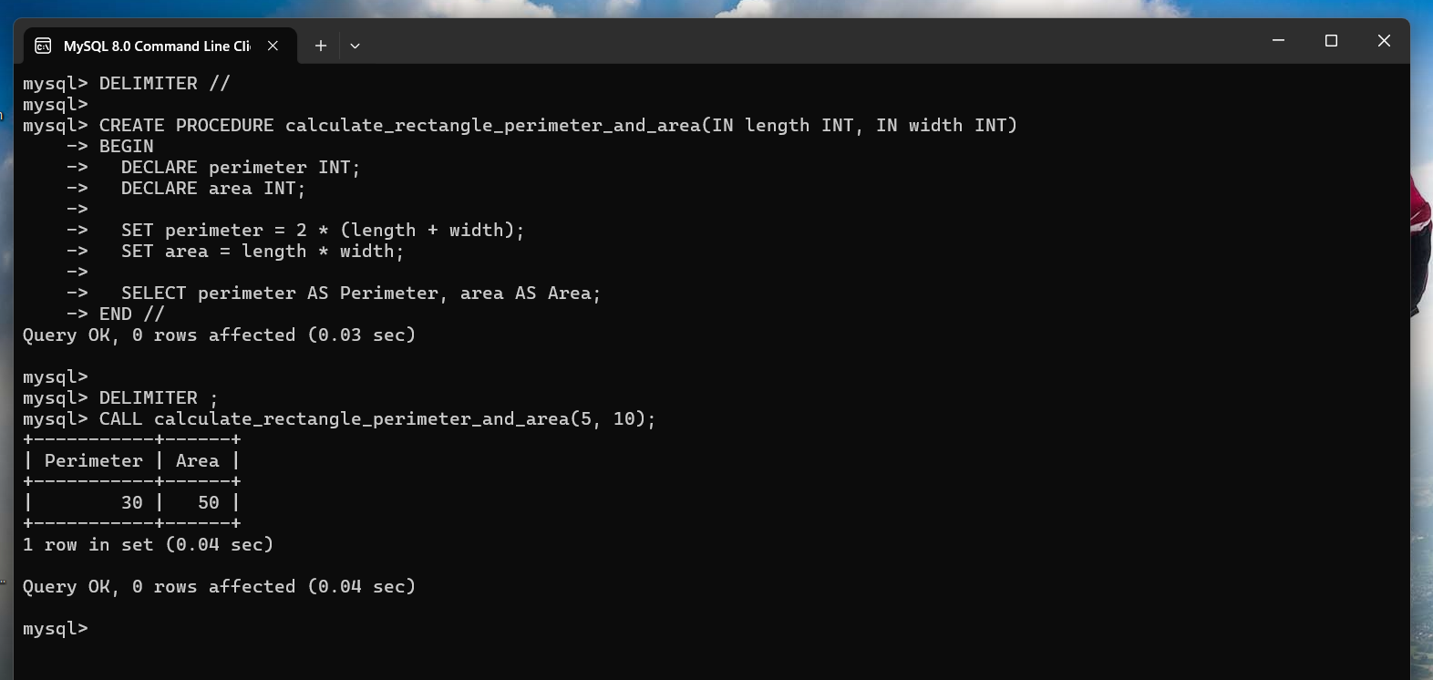

**2.**

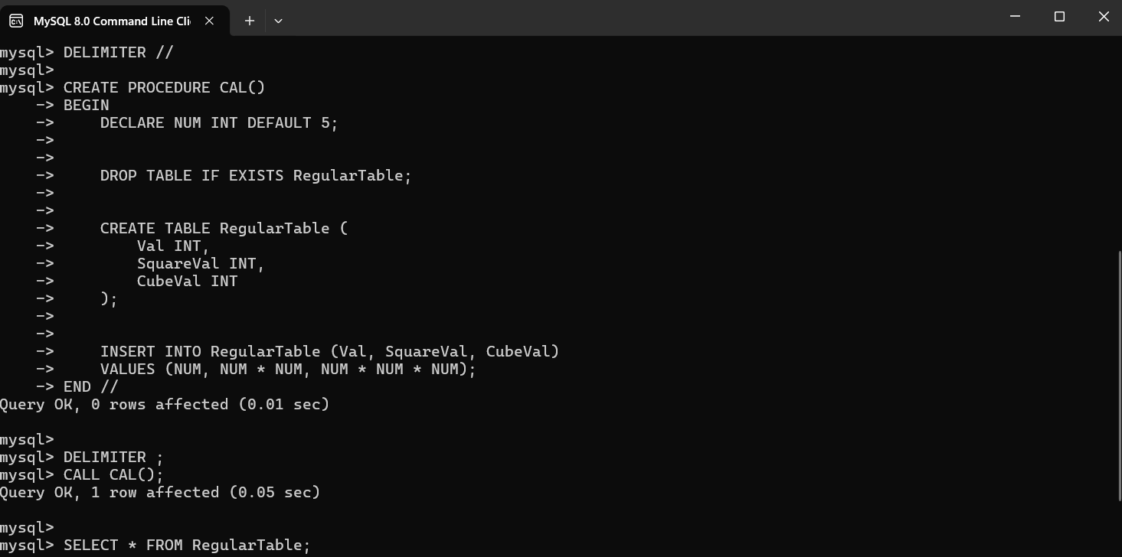

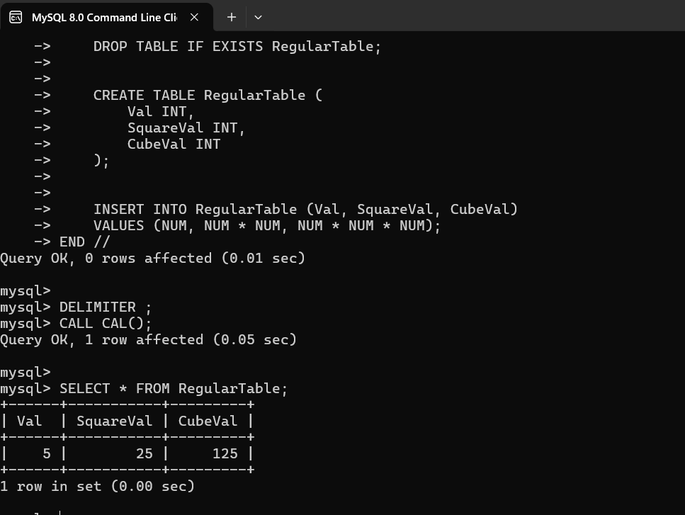

**3.**

DELIMITER //

CREATE PROCEDURE convert_temperature(IN temp_value DOUBLE, IN temp_unit VARCHAR(1))

BEGIN

DECLARE converted_temp DOUBLE;

IF temp_unit = 'F' THEN

SET converted_temp = (temp_value - 32) * 5 / 9;

ELSEIF temp_unit = 'C' THEN

SET converted_temp = (temp_value * 9 / 5) + 32;

ELSE

SIGNAL SQLSTATE '45000' SET MESSAGE_TEXT = 'Invalid temperature unit. Must be "F" or "C".';

END IF;

SELECT converted_temp AS converted_temperature;

END //

DELIMITER ;

CALL convert_temperature(75, 'F'); -- Convert 75 Fahrenheit to Celsius

CALL convert_temperature(25, 'C'); -- Convert 25 Celsius to Fahrenheit

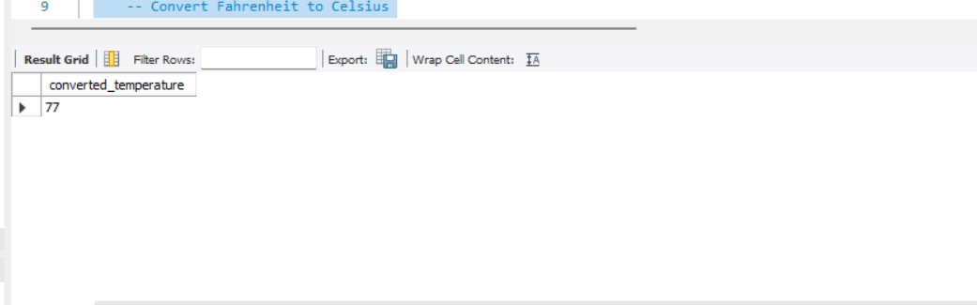

4.

DELIMITER //

CREATE PROCEDURE convert_inches_to_yards_feet_inches(IN total_inches INT)

BEGIN

DECLARE yards INT;

DECLARE feet INT;

DECLARE inches INT;

SET yards = FLOOR(total_inches / 36);

SET feet = FLOOR((total_inches % 36) / 12);

SET inches = total_inches % 12;

SELECT yards AS yards, feet AS feet, inches AS inches;

END //

DELIMITER ;

CALL convert_inches_to_yards_feet_inches(124);

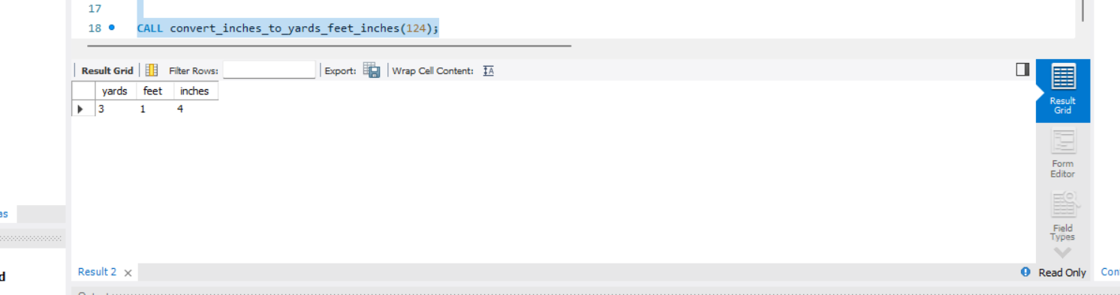

5.

DELIMITER //

CREATE PROCEDURE check_divisible_by_5(IN number INT)

BEGIN

IF number MOD 5 = 0 THEN

SELECT CONCAT(number, ' is divisible by 5.');

ELSE

SELECT CONCAT(number, ' is not divisible by 5.');

END IF;

END //

DELIMITER ;

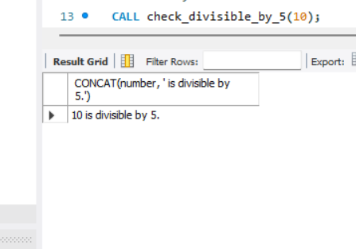

6.

DELIMITER //

CREATE PROCEDURE check_product_greater_than_100(IN num1 DOUBLE, IN num2 DOUBLE)

BEGIN

DECLARE product DOUBLE;

SET product = num1 * num2;

IF product >= 100 THEN

SELECT CONCAT(num1, ' * ', num2, ' = ', product, ', which is greater than or equal to 100.');

ELSE

SELECT CONCAT(num1, ' * ', num2, ' = ', product, ', which is less than 100.');

END IF;

END //

DELIMITER ;

CALL check_product_greater_than_100(10, 12);

